An Empirical Study on Self-Driving

& Electric Vehicle Markets

Table of Contents Page

1. **EXECUTIVE SUMMARY 1**
2. **INTRODUCTION 2**
   1. **BACKGROUND PROBLEM 2**
   2. **OBJECTIVES OF THE PROJECT 2**
   3. **RESEARCH QUESTIONS 2**
   4. **POTENTIAL CONTRIBUTIONS 3**
3. **THEORETICAL BACKGROUND 4**
4. **HYPOTHESIS DEVELOPMENT 7**
5. **METHODOLOGY 10**
   1. **RESEARCH DESIGN 10**
   2. **DATA COLLECTION 11**
   3. **DATA ANALYSIS 13**
6. **RESULTS AND DISCUSSION 15**
7. **CONCLUSIONS 16**
8. **REFERENCES 17**
9. **APPENDIX 19**
   1. **PROJECT SCOPE STATEMENT 19**
   2. **STAKEHOLDER REGISTER 20**
   3. **REQUIREMENTS 22**
   4. **WORK BREAKDOWN STRUCTURE 23**
   5. **GANTT CHART 24**
   6. **RISK BREAKDOWN STRUCTURE 27**
   7. **RISK REGISTER 28**
10. **EXECUTIVE SUMMARY:**

The automotive industry is trending with emerging technologies and are find possibilities in the way we might travel in the future. Major car manufacturers are making significant progress in self driving and electric vehicles in the marker and are testing them in real-life traffic conditions. These technologies have to go through a phase to overcome technical as well as social challenges. The previous studies on consumer provides descriptive analysis and failed to extract insights on consumers’ intention and awareness on self-driving and electric vehicles.

A survey was conducted to obtain data on consumers’ perceptions, their awareness and eventual purchase intention of self-driving and electric vehicles. Survey questions were created based on several factors such as knowledge, government norms, safety features, cost savings, driving range. Based on 129 responses received, two variables decided to have positive impact on purchase intentions of the customer: Feedback from people and Safety Features. The variables were also interpreted in survey questions. Based on results of the survey, influence and feedback from family and friends and safety features have significant impact on the users purchase intention of the self-driving and electric vehicles.

Based on the results, the conclusion is that consumers' purchase intention is heavily dependent on influence and feedback from friends and family and also on the safety features the self-driving and electric vehicles offer to the user. This also shows that customers are comfortable with the technology improvement of self-driving vehicles.

1. **INTRODUCTION:**
   1. **BACKGROUND PROBLEM:**

Electric and Self Driving Vehicles have shown some promising results as an emerging market segment in the automobile industry. Customers across the globe as well as in the United States have shown significant interests towards Electric Vehicles launched by companies such as Tesla, Ford, General Motor Corp etc. Despite these promising signs, the electric vehicle segment has failed to create a concrete customer base in the United States and across the globe alike. There can be several reasons to why the electric vehicles segment has failed to capitalize on a growing demand and there is not any research or market study that has been carried out to understand the reasons behind the problem and why a majority of customers are still choosing to buy conventional vehicles over electric and self-driving vehicles .

* 1. **OBJECTIVES OF THE PROJECT:**

Data analysis includes the collection of customer perception in the form of a survey, that would be administered through a weblink. As part of the analysis, we will shortlist several variables and analyze the dependence and independence of shortlisted variables. In addition to this, we will be understanding and establishing a relation between the variables.

* 1. **RESEARCH QUESTIONS:** 
     1. What does a world of self-driving and electric vehicles look like?
     2. Are self-driving cars safer than conventional cars?
     3. What are the factors affecting the consumers to purchase a self-driving or electric vehicle?
     4. Will technology developments, such as solid-state battery advancements, become key enablers of mass adoption because of the resulting significant increase in battery range and reduction in charging time?
  2. **POTENTIAL CONTRIBUTIONS:**

The major penetration of electric vehicle and self-driving vehicle market would have significant benefits for consumers. Higher vehicle utilization and fuel efficiency provides lower travel cost for the electric vehicle consumers by decreasing utility prices. Electric vehicles are environment friendly and hence it reduces pollution. Also, electric vehicles have 40% fewer parts and therefore, battery replacement and maintenance costs are also 25% less than their internal combustion counterparts. The self-driving vehicles provides a safer travel. A study by the nonprofit Eno Centre for Transportation estimates that if 90% of cars on American roads were autonomous, the number of accidents would fall from 5.5 million a year to 1.3 million, and road deaths from 32,400 to 11,300.26 This would generate a substantial financial benefit in the form of reduced insurance costs. Self-driving cars would also decrease traffic delays on highways and suburban roads. It also makes travel time productive and provides better travel experience. In a nutshell, self-driving and electric vehicle market all together improves the efficiency.

1. **THEORETICAL BACKGROUND:**

As indicated by a report issued by the National Highway Traffic Safety Administration (NHTSA), 90% of all car accidents are because of human mistake. Innovative work in the course of recent years in the car and innovation enterprises have made critical jumps in bringing computerization into our vehicles. More current vehicle models incorporate highlights, for example, versatile voyage control, leaving help, and path keeping help frameworks that would upgrade the wellbeing perspectives while riding these vehicles. The target with such development is to gradually mechanize the driving procedure, i.e., to wipe out the requirement for a human driver to drive these vehicles. Self-driving vehicles are a classification of vehicles that can drive without anyone else with next to zero requirement for a human driver. They sense their general condition with the assistance of cutting-edge systems, for example, RADAR, LIDAR, GPS, and PC vision to explore from inception to goal. There is a great deal of conversation because of Self-driving vehicles in transit we may travel, and legislative organizations are thinking about how to design transportation frameworks for such advances.

The race to create and test Self-driving vehicles has warmed up with major car manufacturers, (for example, Tesla, Audi, and General Motors), technology monsters (i.e., Google, and Apple), and ridesharing administers, (for example, Uber, and Lyft) intensely engaged with revealing their rendition of a driverless vehicle to the overall population. As of the year 2016, six U.S. states – Nevada, Florida, California, Tennessee, Utah, and Michigan – and the District of Columbia have passed laws allowing the testing of Self-driving vehicles on thruways. Furthermore, urban areas like Pittsburgh and San Francisco have opened its entryways for comparable sorts of testing of developing vehicle innovations too. The presentation of testing systems has additionally prompted a great deal of theory on figures anticipating the market entrance of these advancements, which appear to differ broadly – going from 2020 to as late as 2050.

Research has demonstrated that not every single developing innovation are promptly invited into the general public by the overall population. Most advances require many years of improvement and creative market development to immerse their latent capacity markets. And, after its all said and done, notwithstanding some early-adopters, most innovations have a portion of shoppers who will consistently be close-disapproved about them. All things considered, a similar example would follow with Self-driving vehicles and they would need to beat not simply innovative difficulties bramble likewise these social obstructions for effective entrance into the commercial center.

A greater part of the past studies on general suppositions with respect to Self-driving vehicles give in particular illustrative univariate examinations and neglect to give further bits of knowledge because of numerous individual-level qualities on buyers' recognitions and planned selection of these advancements. Indeed, even at an enlightening level, there is little proof of the presence of generational-level contrasts in proposed selection of Self-driving vehicles. This is significant as a great deal of the ongoing conversations have concentrated on the way that less Millennials are getting their driving licenses and their declining examples of vehicle proprietorship. This is as an unmistakable difference to the more seasoned ages who have customarily compared vehicle possession with opportunity/autonomy.

With respect to reasons referenced above, it isn't totally inconceivable that there might be various triggers towards the selection of rising innovations among the various ages. Considering the market capability of Self-driving vehicles, there are intriguing bits of knowledge to be gotten by understanding potential contrasts in generational-level inclinations towards the reception of Self-driving vehicles to anticipate a powerful future with them. Expecting that everybody over an age acts a specific path towards new advancements is itself an expansive based supposition to make. Earlier research has tended to these issues with the distinguishing proof of shopper showcase sections that contain subgroups with comparative social qualities. In light of the huge market capability of Self-driving vehicles, there is a great deal of legitimacy in upgrading our comprehension of such market fragments so as to more readily dissect their triggers for reception and successfully manage tomorrow's approaches.

Thinking about the high initial expense of possessing these advancements, there is a great deal of conversation and discussion on the conceivable rise of inventive transportation modes, for example, shared Self-driving vehicles which could be a cheap, on-request portability administration. Past research has just reproduced mutual Self-driving vehicles in a gridded city organize and indicated cost motivating forces in contrast with independently possessing and working vehicles. These advancements have additionally been quickened by the raid of well-known ridesharing administrations, for example, Uber and Lyft with the intend to build up their forms of Self-driving vehicles, in this manner underlining the need to break down potential moves in family unit vehicle proprietorship with the presentation of shared Self-driving vehicles. While past investigations have tended to changes in family vehicle proprietorship because of the development of vehicle and ride-sharing administrations, there haven't been any advances in understanding these impacts with the presentation of shared Self-driving vehicles, to the best of the creator's information.

1. **HYPOTHESIS DEVELOPMENT:**

This study proposes several research hypotheses regarding the factors influencing consumer acceptance of electric vehicles.

The electric vehicle market is dominated by globally established players such as Tesla (US), BYD (China), BMW (Germany), Volkswagen (Germany), and Nissan (Japan). These companies developed new products, adopted expansion strategies, and worked on acquisitions to gain traction in this high-growth electric vehicle market.

The future is expected to be bright and with time technological improvements and developments, the electric vehicles can be more affordable. The electric vehicles provide several advantages, such as a higher efficiency in energy use and reduction in emissions and the energy needed to power the vehicle can easily be obtained from any electricity source. However, electric vehicles only have a limited distance which can be driven before the battery is depleted and recharging the battery can take a substantial amount of time. Furthermore, the battery packs are heavy and are considerably expensive (Argueta and Holms 2010).

 The adoption of electric vehicles is impacted by several factors such as customer attitude, subject knowledge, government norms, cost savings, charging stations, driving range, safety features, technology development and market share.

**4.1 Purchase Intention**

Purchase intention refers to the customers’ ability and necessity to purchase based on certain factors and can be measured on the possibility of purchasing. Some of the factors determining purchasing intentions are customers attitude, knowledge, government norms. The customer attitude includes the external influence of society and people feedback on purchases. The influence can also be internal (family, friends) and external (media, expert opinions). Government norms include allowance on income tax, discounts on purchases, allowances on parking, preferences on HOV lanes

***Hypothesis 1:*** *Consumers attitude toward self-driving/electric vehicles has a positive impact on their purchase intention.*

***Hypothesis 2:*** *Consumers subjective knowledge regarding self-driving/electric vehicles has a positive impact on the purchase intention.*

***Hypothesis 3:*** *Government norms on electric vehicles has a positive impact on purchase intention*

**4.2 Cost Savings**

Lane and Potter (2006), mentions that purchase price is a deciding factor in determining vehicle acceptance. Now with Tesla's model starting as low as $20,000 and to factor in the savings on fuel/gas, the cost savings on purchasing the electronic vehicles can have an effect on customers.

***Hypothesis 4:*** *Annual cost savings have a positive effect on purchase intention*

**4.3 Charging Stations**

Charging stations are absolutely essential for an electric vehicle. Without a charging station you cannot charge your battery and in particular, public charging stations are very important. There are several barriers for public charging stations such as regulatory uncertainty, a lack of infrastructure and high cost.

***Hypothesis 5:*** *Charging station accessibility has no effect on electric vehicle purchase intention*

***Hypothesis 6:*** *Regular charging time has no effect on electric vehicle purchase intention*

**4.4 Driving Range**

Driving range is another factor influencing electric vehicle adoption and purchasing decision. Most drives are being afraid of battery depletion before arriving at the destination and hence choose to use electric vehicle for normal range drives and avoid them for road trips and vacations

***Hypothesis 7:*** *Driving range has a positive effect on electric vehicle purchase intention*

**4.5 Safety Features**

Customers interest in adopting enhanced safety/automation features plays a role in their vehicular purchase. Customers driving history also plays a factor in deciding on the safety features of the car.

***Hypothesis 8:*** *Safety Features on the vehicle has a positive effect on electric vehicle purchase intention*

**4.6 Research and Technology Developmen**t

While some of the safety features are currently only available in high-end models, the preferences about adding enhanced safety/automation features to enhance their driving experience will be included in the study. The battery has seen clear technological improvements, thereby making it cheaper, lighter and giving it a bigger range. Technological developments as well as economies of scale could play a factor in improved sales of electric vehicles.

***Hypothesis 9:*** *Technology improvements has a positive effect on electric vehicle purchase*

1. **METHODOLOGY:**

**5.1 RESEARCH DESIGN:**

The research design is a framework for planning the research and answering the research questions.

A very significant decision in research design process is the choice to be made regarding research approach since it determines how relevant information for a study will be obtained. This empirical analysis majorly involves Correlational and Comparative research design to derive at the hypothesis. We need primary data (through online survey) using random sampling method as well as secondary data (through statistics and publications available online). This study employs a mixed type of sources including well-structed questionnaire (online survey) along with secondary data from online sources. The variables required for each hypothesis is mentioned in the below data collection phase. The participants for our online survey would be students, friends, professors and colleagues. The estimated timescale for this research to complete would be 5-6 months.

Few examples of online survey questionnaire would be:

1. Demographics question (such as age, gender, annual income)
2. Are you presently using self-driving vehicle or EV?
3. Are you familiar with self-driving vehicle or EV?
4. Commute characteristics (such as total time spent on commute per day, commonly used mode for various trips)
5. Crash history (such as vehicular damage level, injury severity level)
6. Will you buy an EV because it saves cost from better fuel economy and has positive environmental impact?

Few online sources referred for data collection:

<https://www.marketwatch.com/investing/stock/tsla/financials/cash-flow>

<https://evadoption.com/ev-market-share/ev-market-share-state/>

<https://evadoption.com/research-statistics/>

**5.2 DATA COLLECTION:**

After deciding the kind of data needed, we will have to decide how and where we will collect it, and this involves the process of data collection. For the purposes of this research, we will be collecting data through an online survey with at least 150-200 respondents, along with secondary data.

**1. Purchase Intention:**

Factors influencing consumers to buy an electric vehicle or self-driving vehicle:

This section elicited consumer demographics (such as age, gender, annual household income range, place they live in), information regarding their current commute characteristics (such as total time spent on commute per day, commonly used mode for various trips, number of vehicles in the household) and user’s attitude towards electric and autonomous vehicles. The influence to own an electric or self-driving vehicle can be formed by internal and external factors, like knowledge about the technology or words from friends and family, to the media marketing and government incentives. To extend as an example, certain attitudes like the thought of helping out to ease global warming by driving an electric vehicle or being interested in the technology and to be invested in the future of automotive industry can make a consumer lean towards purchase of electric or autonomous vehicles. This data can be collected through an **online survey** with close-ended questionnaire.

**2. Cost Savings:**

Do EV drivers enjoy saving money & the planet with their vehicles:

We can derive this through **online survey** using closed-ended questionnaire by gathering information regarding their opinion on buying an electric vehicle because they consider that it saves cost from better fuel economy, does it have less dependence on non-renewable resources and positive environmental impact.

**3. Charging Stations:**

Purchase of electric vehicle vs charging stations:

This section involves usage of both secondary data and data from **online survey**, We would be using number of charging stations in each state that has been  published in the **secondary data sources** and the geographic data from the **online** **survey** (place they live in), we will be able to produce a relationship between purchase of electric vehicles in particular state is dependent on charging stations.

**4. Driving Range:**

Using information regarding their current commute characteristics (such as total time spent on commute per day, commonly used mode for various trips) from the **online survey** using closed-ended questionnaire, we will be able to arrive at the hypothesis.

**5.Safety Features:**

Consumer perception on safety and benefits of autonomous vehicles:

This section extracts the information using **online survey**, using information such as user’s familiarity with autonomous vehicles, safety rating scale, their crash history (such as vehicular damage level, injury severity level) using closed-ended questions with a rating scale and if they are familiar then the other information regarding benefits can also be gathered through **online survey** by considering features (such as fewer traffic crashes, less stressful driving experience, more productive use of travel time, lower car insurance rates, increased fuel efficiency, lower vehicle emissions). This can also be performed using closed-ended questions using options (like unlikely, unsure, likely)

**6. Research and Technology Development:**

This section extracts the information using ***online survey*** by asking questions like what would make one more interested in an electric vehicles or autonomous vehicles would help arrive at the results. These would include variables like range, charging speed, quite comfort, speed, continuous software updates to driving technology.

**5.3 DATA ANALYSIS:**

To answer the research questions, we will have to analyze the collected data and the type of

analysis would differ for each hypothesis. We will be using applications like Excel or SPSS to

analyze our data. We are collecting data through survey and working also along with secondary

data to arrive at conclusions. This would mean that we need to perform quantitative and

qualitative analysis based on the variables considered for each hypothesis.

Using variables that reflect peoples’ opinion in relation to cost savings, driving range and

perception of safety would lean more towards Qualitative analysis. While using number of

vehicles, employees and market share would require quantitative analysis as well.

**1. Purchase Intention:**

For this purpose, we will have to perform quantitative and qualitative analysis because it

involves both numeric data and words.

**2. Cost Savings:**

As it involves opinions about electric vehicles which contains only words as data from the

online survey, this can be performed using qualitative analysis.

**3. Charging Stations:**

As this will have number of charging stations in numeric data and also involves words as data,

for the location, we need to use both qualitative and quantitative analysis.

**4. Driving Range:**

As this includes commute characteristics which will have both numeric data and words,

therefore, we will need to perform both qualitative and quantitative analysis.

**5.Safety Features:**

This section includes rating scale which would be numeric data as well as opinions about benefits which will be words and hence, we need to perform both qualitative and quantitative analysis

**6. Research and Technology Development:**

This section majorly includes analyzing words so we will be performing qualitative analysis.

1. **RESULTS AND DISCUSSION:**

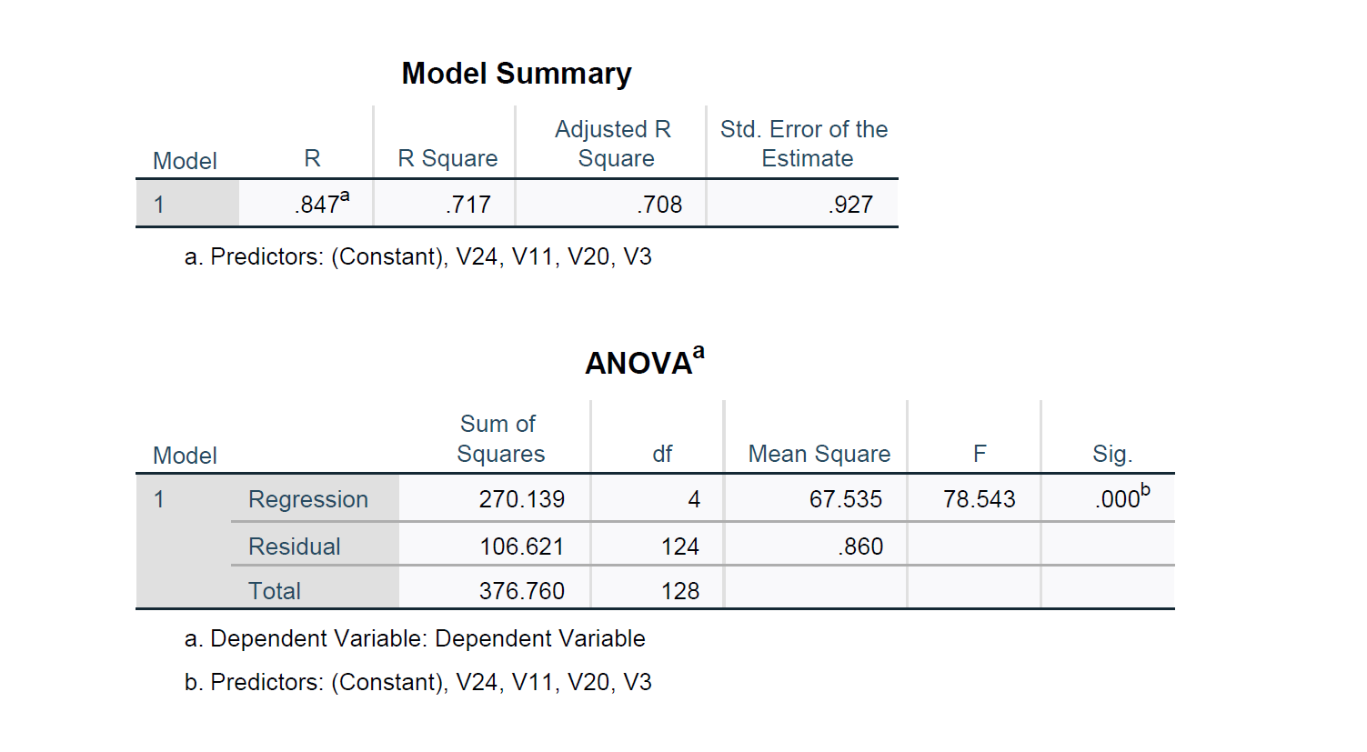

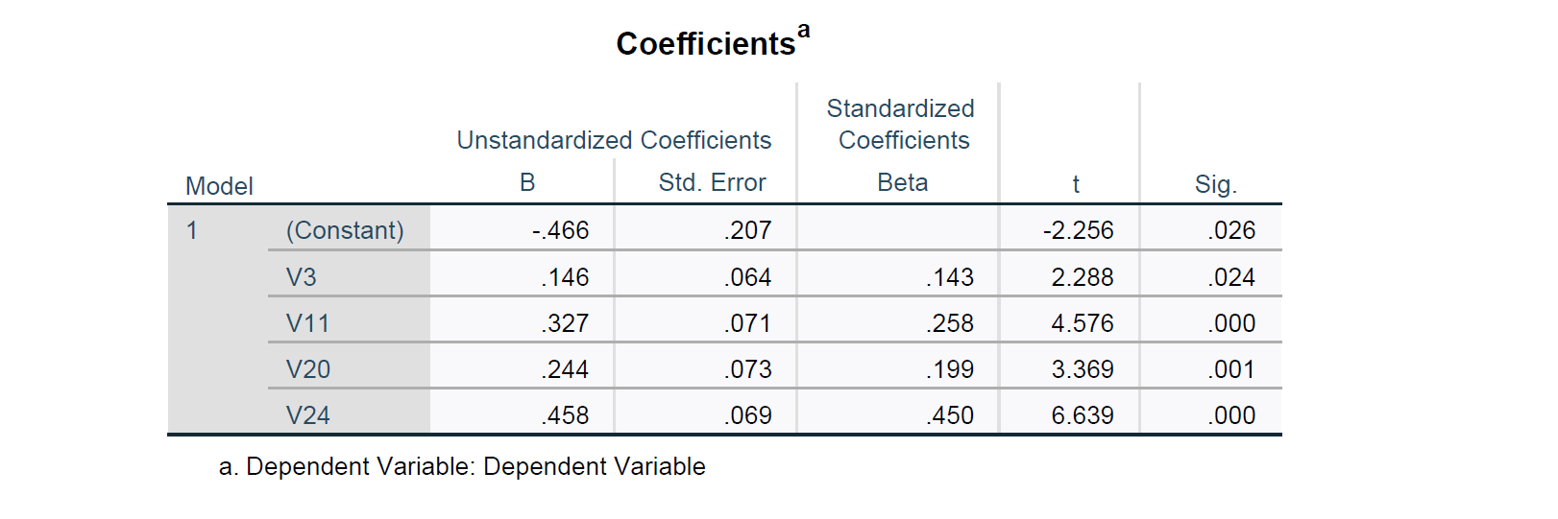

The above-mentioned SPSS output is the final model we reached after iterating with 28 different independent variables from the survey and Eliminating the statistically insignificant variables depending on their P-Value. From the above-mentioned model, we see that V3 and V20 have P-value less that 0.05 and hence show a degree of statistical significance with the dependent variable. Also, from the R-squared value we can see that 71.7% variation in dependent variable which is the purchase intention is explained by the independent variables

1. **CONCLUSIONS**:

Based on the analysis for different hypothesis, our results show that a user’s purchase intention of the self-driving and electric vehicle depends on the feedback, reviews and influence of people and safety features of the cars.

The impact of charging stations has no impact on the purchase intention, while the cost savings made from discounts, Government norms has no impact on purchase decision. Current travel characteristics has no influences in understanding consumers’ probability of purchasing self-driving and electric vehicles.

The analysis shows that customers feel comfortable with suggestions provided by users who has already bought the vehicles, their experience in using it and the safety features it offers. Based on this study, more analysis can be performed after narrowing down the factors on user experience and safety features.

While the results from this exercise could be used to enhance our understanding of various consumer market segments, this does not, as of yet, provide any conclusive evidence of their behavior towards intended adoption of self-driving vehicles.

1. **APPENDIX:** 
   1. **PROJECT SCOPE STATEMENT:**

|  |  |  |  |  |
| --- | --- | --- | --- | --- |
| **PROJECT SCOPE STATEMENT** | | | | |
| **Project Name** | **An Empirical Study on Self driving and Electric Vehicle Markets** | | |
| **Project Sponsor** | Jane Doe | **Project Manager** | John Doe |
| **Approval Date** | 2/18/2020 | **Revision Date** | 2/20/2020 |
| **Project Scope** | **IN SCOPE:** 1. Identify several variables, that can be measured  2. Design a Survey Basing on the variables  3. Administer the survey  4. Analyze the Data obtained   **OUT OF SCOPE:** * Study of complex sales inquiries such as partnerships etc. | | |
| **Project Deliverables** | - Customer Perception of Electric and Self Driving Vehicles  - Data sets collected from research | | |
| **Benefits of Study** | * Study Provides Current and Future Market Trends * Study provides sources to plan future course of action | | |
| **Acceptance Criteria** | The stakeholders will accept the project when the deliverables are agreed to meet it needs and are signed off. | | |
| **Constraints** | - Study will not provide comparison with other directorate within the organization - Study is based on surveys, there would be considerable margin of error | | |
| **Assumptions** | Sample is familiar with Electric and Self Driving Vehicles | | |

* 1. **STAKEHOLDER REGISTER:**

|  |  |  |  |  |  |  |  |
| --- | --- | --- | --- | --- | --- | --- | --- |
| STAKEHOLDER REGISTER | | | | | | | |
| Project Manager | John Doe | | | Project Phase | | Initiation | |
|  | | | | | | | |
| Name | Role | Contact | Category | Interest | Influence | Expectations | Communication |
| Andy Williams | VP Operations | Ph: 214-111-1234  Email: awilliams@tesla.com | Internal | High | High | Improvement in technology and customer satisfaction | Email |
| Brandon Carr | VP Sales | Ph: 214-111-1231  Email: bcarr@tesla.com | Internal | High | High | Sales and revenue growth | Email |
| Catherine Theresa | VP Marketing | Ph: 214-111-1232  Email: ctheresa@tesla.com | Internal | High | High | Customer satisfaction | Email |
| Doug Peters | Dev Manager | Ph: 214-111-1238  Email: dpeters@tesla.com | Internal | High | High | Development new features on time | Email and Phone |
| Elaine Bennes | Development Lead | Ph: 214-111-8765  Email: ebennes@tesla.com | Internal | Medium | Low | Development completion on time | Email and Phone |
| Frank Cook | IT Portfolio Manager | Ph: 214-111-1239  Email: fcook@tesla.com | Internal | High | High | Manage development efforts and resources | Email and Phone |
| Graham Thorpe | QA Manager | Ph: 214-111-1222  Email: gthorpe@tesla.com | Internal | Medium | Low | Manage QA resources and meet expectation of the business | Email and Phone |
| Hick Hammond | QA Analyst Lead | Ph: 214-111-1298  Email: hhammond@tesla.com | Internal | Medium | Low | Investigate and identify defects prior to implementation | Email and Phone |
| Indira Nooyi | Data Analyst | Ph: 214-111-8761  Email: inooyi@tesla.com | Internal | High | Low | Analyze data and query historic data as required | Email and Phone |
| Javier Bardem | Business Analyst | Ph: 214-111-0987  Email: jbardem@tesla.com | Internal | High | Medium | Provide requirement on time | Email and Phone |
| Kayla Smith | Operations Manager | Ph: 214-111-1254  Email: ksmith@tesla.com | Internal | Medium | Medium | Manage operational process | Email and Phone |
| Leonard Di Caprio | Sales Manager | Ph: 214-111-5432  Email: ldcaprio@tesla.com | Internal | Medium | Medium | Manage Sales process | Email and Phone |
| Martha Stewart | Director of Accounting | Ph: 214-111-2222  Email: mstewart@tesla.com | Internal | High | High | Manage sales and revenues | Email and Phone |
| Nanette Jackson | Project Manager | Ph: 214-111-1098  Email: njackson@tesla.com | Internal | High | High | Manage project | Email and Phone |

* 1. **REQUIREMENTS:**

Business Requirements

* 1. Gather current process and technologies
* As part of study, we need to understand the current business models and future road map and enhancements planned.
* The improvements planned will be factored in to analyze the business impact on customer experience, sales, efficiency and profits
* Improvements that are identified as non-dependencies will be not considered in scope of analysis
  1. Identify Dependent and independent variable
* Dependent and independent variables need to be reviewed and finalized based on research on current business models and variables, its impact on financial data such as sales and revenue.
* Some of variables identified are revenue, sales, production capacities, range of hybrid vehicle driving or mileage, no of employees.
  1. Create Reporting data table to store data for analysis
* The reporting database and table need to be created to extract and store data for analysis
* The data should be read only for users so that data cannot be modified
  1. **WORK BREAKDOWN STRUCTURE:**

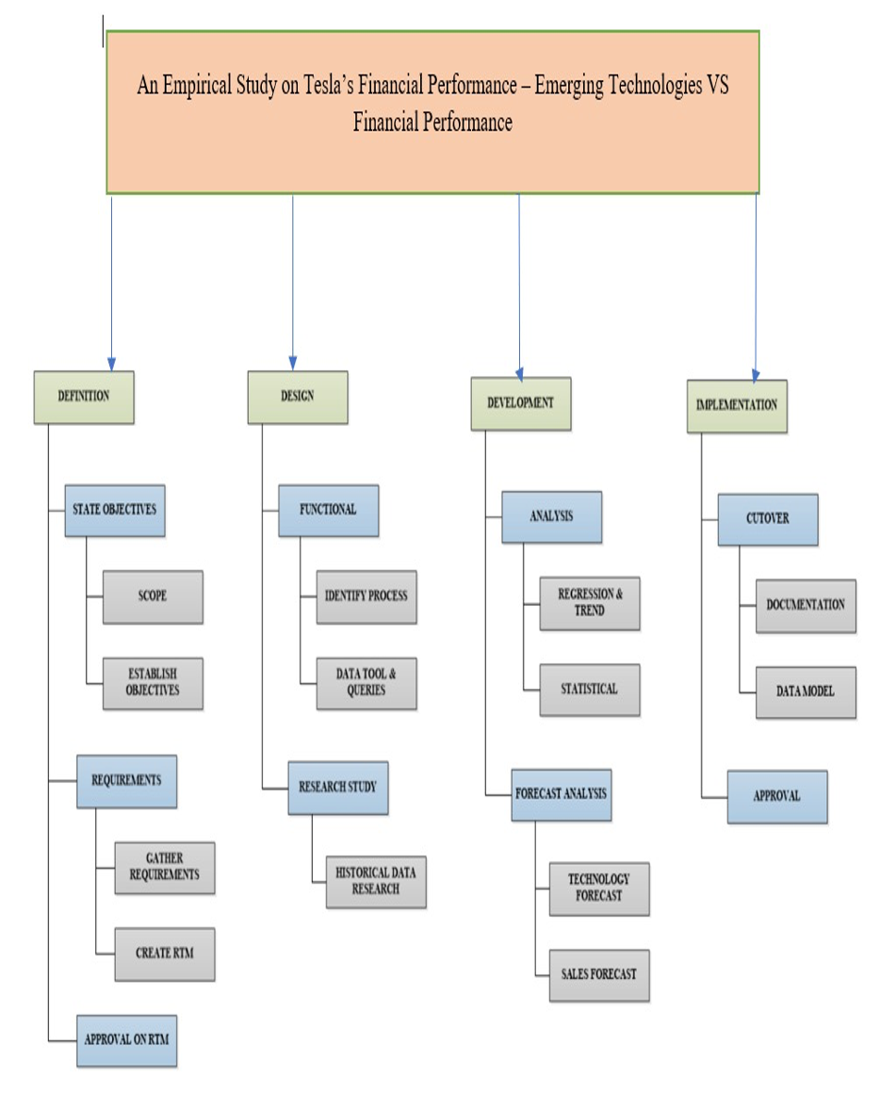

* 1. **RISK BREAKDOWN STRUCTURE:**

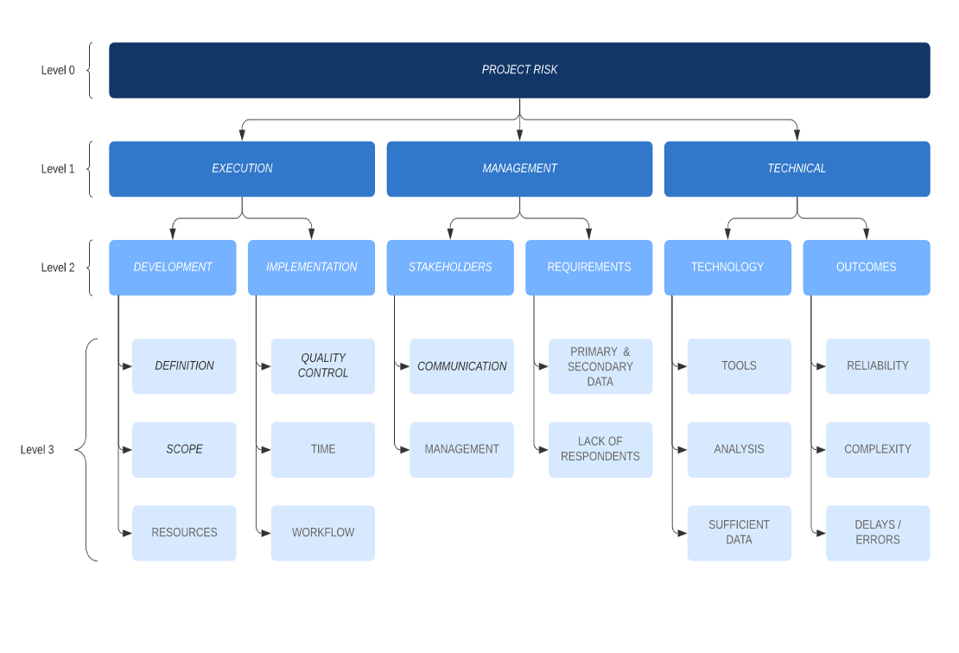

* 1. **RISK REGISTER:**

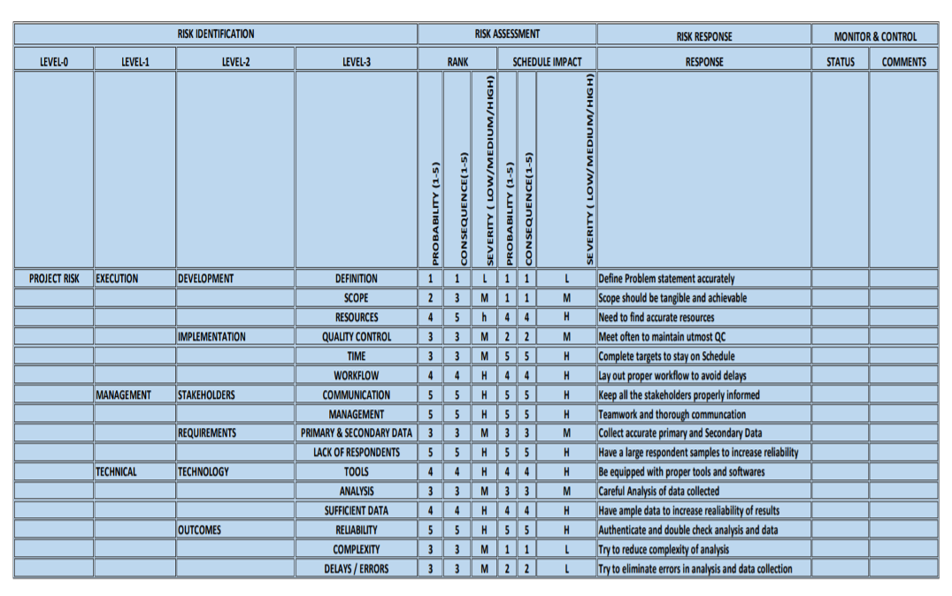

1. **REFERENCES**:
2. Yan,Qingyou;Qin,Guangyu;Zhang,Meijuan;Xiao,Bowen, Research on Real Purchasing Behavior Analysis of Electric Cars in Beijing Based on Structural Equation Modeling and Multinomial Logit Model. 2019, 11, 5890, 1-15
3. Tu,Jui-Che;Yang,Chun;, Key Factors Influencing Consumers’ Purchase of Electric Vehicles. 2019,11,3863,1-22
4. Liu,Yixuan; Whinston, Andrew, ,NBER Conference on the Economics of Autonomous and Electric Vehicles
5. Lane, B. and Potter, S. 2006. The adoption of cleaner vehicles in the UK: exploring the consumer attitude-action gap. Journal of Cleaner Production, 15(2007), 1085-1092.
6. Rezwani,Zeinab;Jansson,Johan;Bodin,Jan; Advances in consumer electric vehicle adoption research: A review and research agenda. 2015,34,122-136
7. Argueta,Roy;Holms,Campbell;A Technical Research Report: The Electric Vehicle. 2010,Technical research
8. Electric Vehicle Market by Vehicle (Passenger Cars & Commercial Vehicles), Vehicle Class (Mid-priced & Luxury), Propulsion (BEV, PHEV & FCEV), EV Sales (OEMs/Models) Charging Station (Normal & Super) & Region - Global Forecast to 2030
9. BikePGH. (2017). The Age of Autonomous Vehicles: AV Survey Results. Retrieved from http:// www.bikepgh.org/resources/save/survey/ (May 08, 2017).
10. Bloomberg. (2016). Public Perceptions of Driverless Cars. Retrieved from https:// newsroom.statefarm.com/download/271091/bloombergstatefarmsurveyreport-final.pdf (May 08, 2017).
11. Autonomous Cars: Self-Driving the New Auto Industry Paradigm, MORGAN STANLEY RESEARCH, November 6, 2013.
12. Gurjashan Singh Pannu, Mohammad Dawud Ansar, Pritha Gupta, Design and Implementation of Autonomous Car using Raspberry Pi, International Journal of Computer Applications (0975-8887) Volume 113-No. 9, March 2015
13. Bonnefon, J-F., Shariff, A., Rahwan, I. (2016). The social dilemma of autonomous vehicles. Retrieved from: https://arxiv.org/ftp/arxiv/papers/1510/1510.03346.pdf (January 12, 2017)